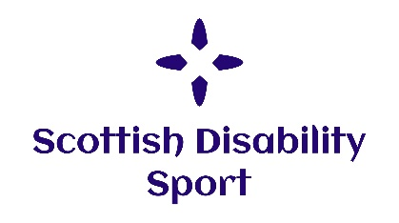
VISUAL IMPAIRMENT SPORT ENGAGEMENT DAY

Saturday 11th November 2017

10.30am – 4.00pm

Scotstoun Leisure Centre

122 Danes Drive, Glasgow G14 9HD
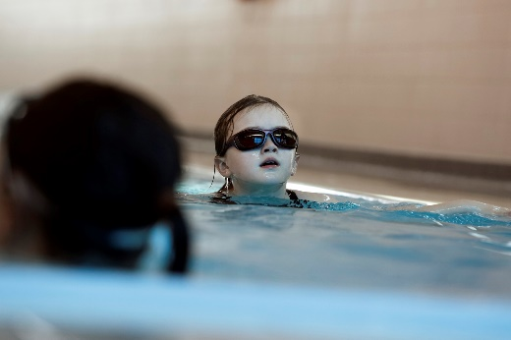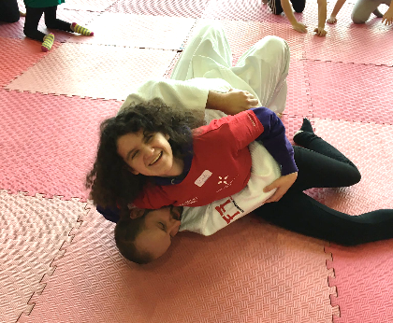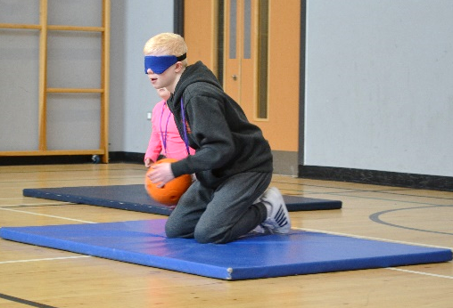

Scottish Disability Sport is delighted to be working in partnership with Judo Scotland, Scottish Football Association, Scottish Swimming, Scottish Athletics, Blazing Saddles and Goalball UK to offer a unique experience of athletics, cycling, football, goalball, judo and swimming.
This event is specifically designed to introduce children, young people and adults with a visual impairment to sport and support regular participation and engagement in sport.
For participants aged 10+ years – registration is essential. For more information or to book a place on the day please contact:
Email: admin@scottishdisabilitysport.com
Phone: 0131 317 1130
For public transport information please see the SPT website at: www.spt.co.uk

