CHIEF EXECUTIVE OFFICER
Dynamic Welsh national sports organisation, attractive package and the opportunity to transform lives
Disability Sport Wales is seeking a highly skilled Chief Executive Officer to join a team dedicated to supporting the sport and physical recreation sector to create an inclusive environment, where disabled people can be hooked on sport, and where athletes become champions
Salary: Attractive - based on relevant experience and subject to negotiation
Employment Type: Full time

The Company:
Disability Sport Wales is the lead organisation for disability sport in Wales. We are committed to supporting the Sector Vision of ‘Uniting a proud sporting Nation’, where every (disabled) person is hooked on sport, and we create a Nation of Champions. Disability Sport Wales transforms lives and does this by creating choice and opportunity through the provision of high quality education, training and learning opportunities, the nurturing of talent, and the fine tuning of elite performers.

The Role:
The CEO will be responsible for the successful implementation of the DSW vision and mission. Operating within a high performing organisation, the role will focus on leadership, motivation, transformation and accountability. In addition, the CEO will be responsible for managing sufficient resources to deliver the vision through existing and new income streams. The CEO, working closely with the Senior Management Team and Board, will be responsible for the management of the governance structure and delivery of the business plan. We are looking for a full-time CEO with a strong inclusive philosophy, who is committed to equality and diversity, leading a team who drive transformational change within the sport and physical recreation sector, ultimately transforming the lives of disabled people. An attractive salary package is available subject to experience and negotiation.
- Great opportunities for continuing professional learning
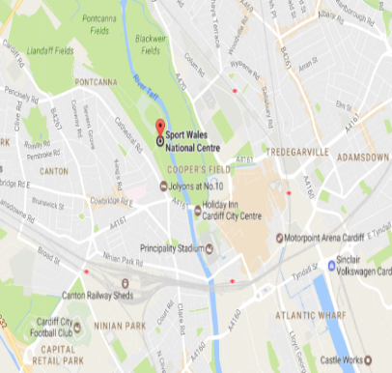
- Leading a dynamic, committed team
- Opportunity to lead both community and elite sport programmes

Head Office Location:
The Disability Sport Wales head office is housed within the Sport Wales National Centre, Sophia Gardens in the heart of Cardiff. Situated next to Bute Park and the SWALEC National Cricket Stadium, with significant free parking, and a sporting buzz. The CEO’s office location is negotiable. Google maps

Why should you apply for the job?
- Be part of a strong, supportive and proactive team
- Work for an equitable and diverse employer, with strong professional ethics and values
- Opportunity to transform lives and support the delivery of inclusive sport and physical recreation within Wales

Apply to: Business Support Manager (CEO2017), Disability Sport Wales, c/o Sport Wales National Centre, Sophia Gardens, Cardiff, CF11 9SW.
Email: claire.venn@disabilitysportwales.com
Tel: 02920 334923
Deadline for Application: Friday 17th March 2017, 5pm
Or visit: www.disabilitysportwales.com
This post is supported by Sport Wales

